Use Case Diagrams

Figure 1: Use case diagram 1

Figure 2: Use case diagram 2

Figure 3: Use case diagram 3

Figure 4: Use case diagram 4

Figure 5: Use case diagram 5

Figure 6: Use case diagram 6

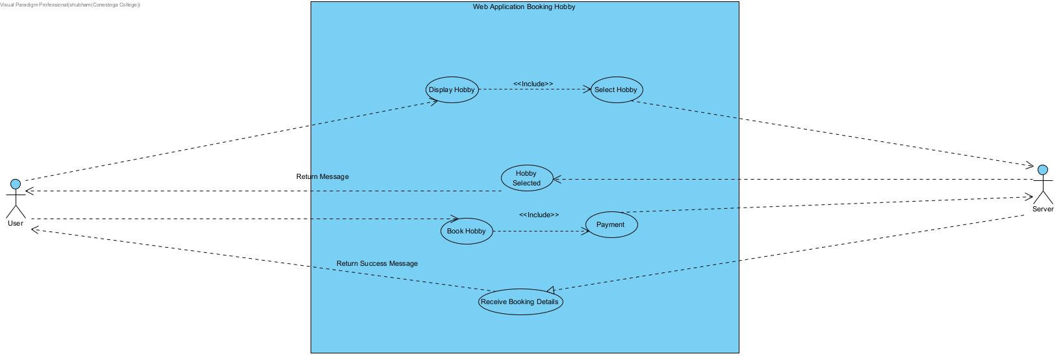

Figure 7: Use case diagram 7